bibliographic Information ツ

Author(s):
Jiali Xu and Di Wang and Maosheng Liao and Wenshuai Shen
Title of article or book (if a chapter in a book, put the chapter # and title here, and put the title of the book in “Title of publication”):
Journal of Physics: Conference Series
Title of publication, including Vol., Num., date (if article in magazine, newspaper, or journal):
Research of Cartographer Graph Optimization Algorithm Based on Indoor Mobile Robot
Page numbers (if article in magazine, newspaper, or journal):
1-18
Publisher:
IOP Publishing
Date published:
Nov 1 2020
URL (if applicable):
https://iopscience.iop.org/article/10.1088/1742-6596/1651/1/012120/meta https://iopscience.iop.org/article/10.1088/1742-6596/1651/1/012120/pdf
MLA citation:
Xu1, Jiali, et al. “IOPscience.” Journal of Physics: Conference Series, IOP Publishing, 1 Nov. 2020, iopscience.iop.org/article/10.1088/1742-6596/1651/1/012120/meta.

Direct quotes: Include Page #s (For each quote, provide some context and/or analysis; you may also want to re-state the information in your own words. Quotes from your sources, and your understanding of them, will make up the bulk of your literature review)
- 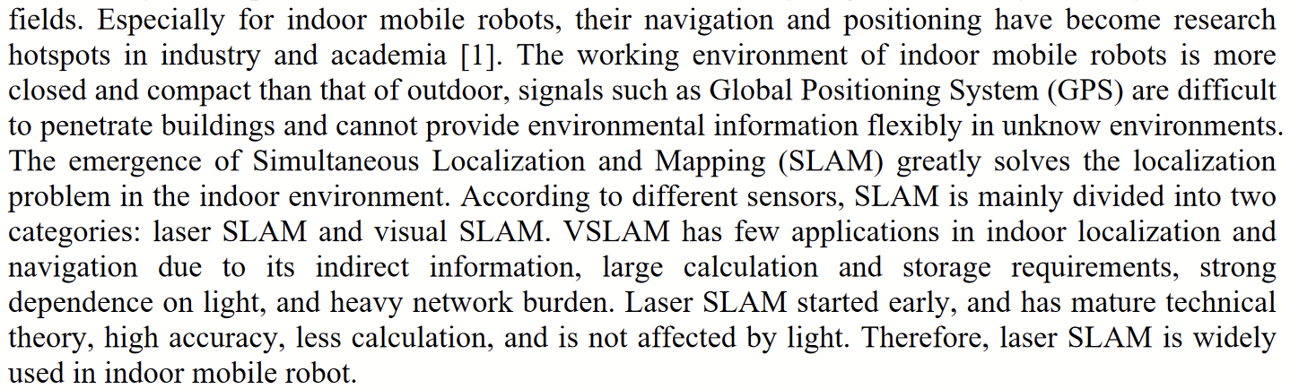p1
- 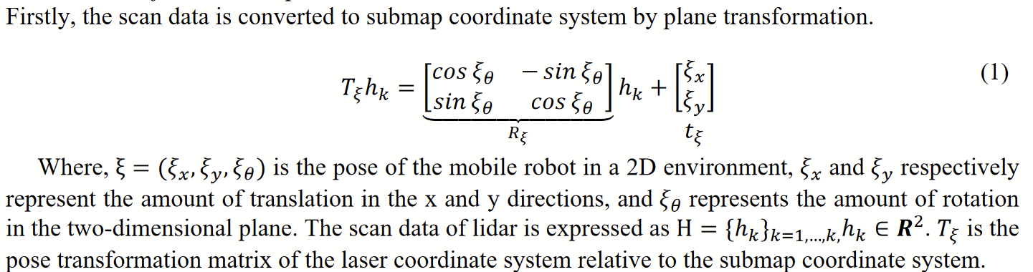p2
- 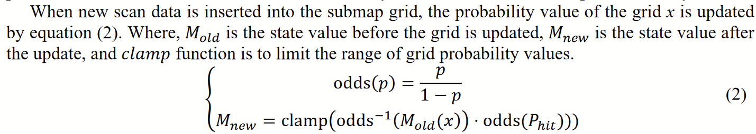p2
- 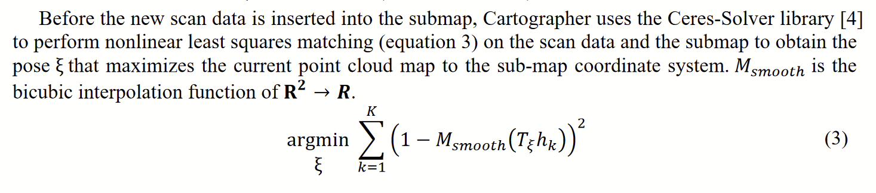p2
- 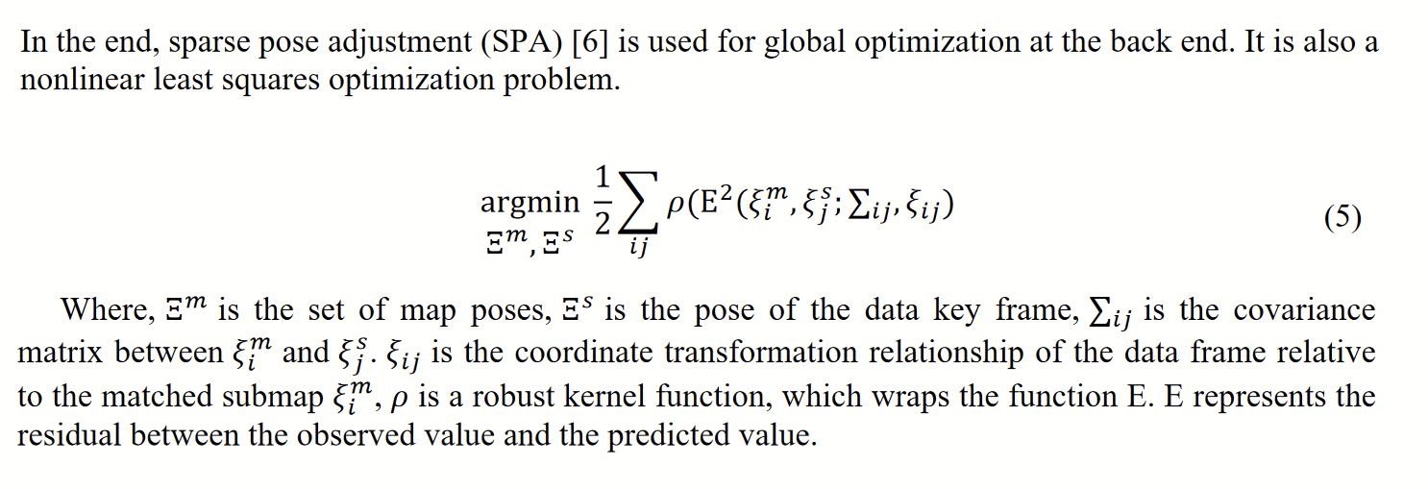p3
- 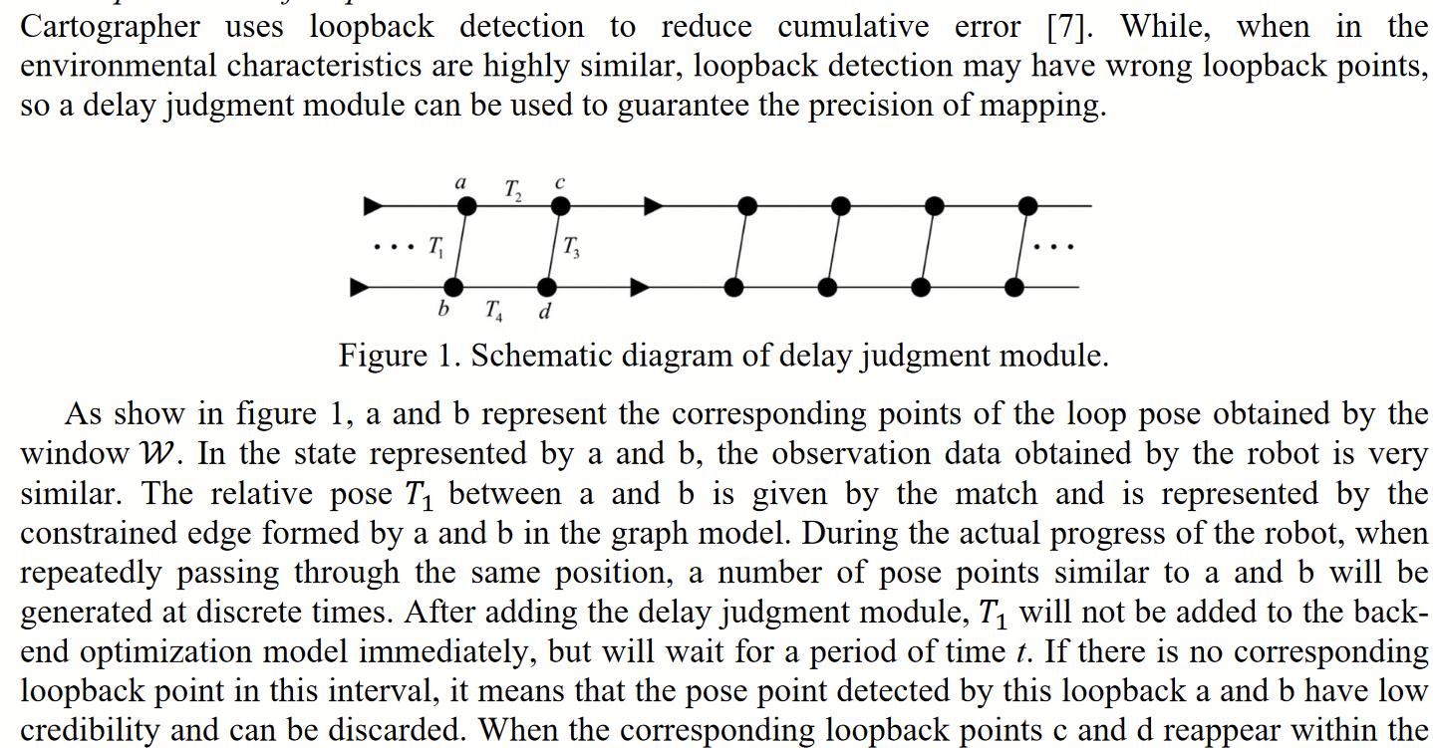p3
- 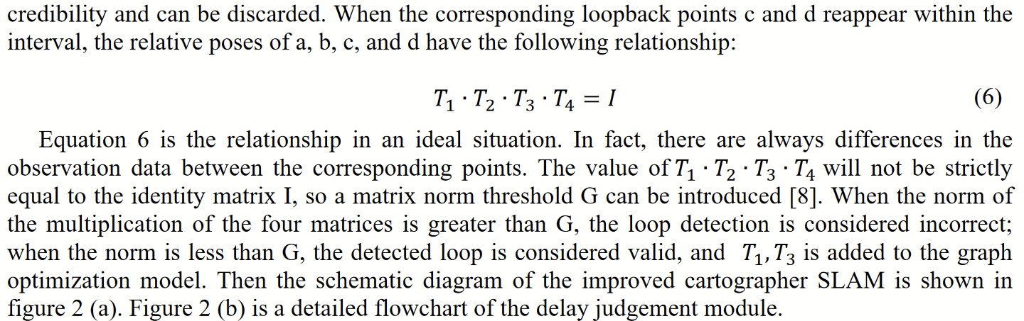p3
- 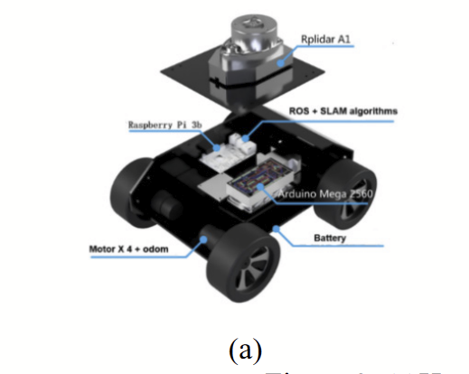p4

Paraphrased Notes: Include Page #s (This is a space for you to track the flow of information, and the ways in which the article engages with other works.)
Google cartographer is weirdly different from gmapping in a way I wouldn't have expected, they are similar but weirdly different.

Summary of Source (2-4 sentences)

Cartogropher mapping is a form of 2d mapping that takes the laserscan data and adds it to a submap, puts that submap on the main map, and then runs a probability check to see how likely it is to be real. Then, it does some really interesting loopback detections be comparing submaps and predicting future submaps.
Does this help me answer my question? Why or why not?
Yep! Talks about another form of lidar mapping.

Lingering Questions
How many more do I have to dooooo

Connections to other sources
So many, slam, robots, the works.

